Cybersecurity Governance

Threat Landscape

Board of Directors Liability

In re Caremark Int’l Inc. Deriv. Litig., 698 A.2d 959 (Del. Ch. 1996)

    - A board can be liable to shareholders if it “utterly failed to implement any reporting or information system or controls,” or “having implemented such a system or controls, consciously failed to monitor or oversee its operations.”

    - The court found that liability “requires a showing that the directors knew that they were not discharging their fiduciary obligations.”

Wyndham Hotels (Palkon v. Holmes), No. 2:14-cv-01234, 2014 WL 5341880 (D.N.J. Oct. 20, 2014).

    - Shareholder case dismissed based on 14 Board discussions about security

    - “Board members had already discussed the cyber-attacks at fourteen meetings from October 2008 to August 2012. ‘At every quarterly Board meeting, the General Counsel gave a presentation regarding the Breaches, and/or [WWC’s] data-security generally.’”

Heavier Regulation

European Union, General Data Protection Regulation (GDPR)
(effective May 25, 2018)

Key Features:
- Strict Protection of Personal Data – including online identifiers
- Data Protection Officer – independent oversight required for:
Profiling or processing of voluminous or sensitive data
- Privacy by Default – with data protection impact assessments (DPIAs)
- Data Subject Rights – individual rights to access, correct, delete data
- Data Breach Notification – to authorities within 72 hours
- Trans-Border Transfers –requires BCRs, model contract, or Privacy Shield
- Penalties – up to 4% of global revenue (“turnover”) or 20 mln euros

Incident Response

Timeline

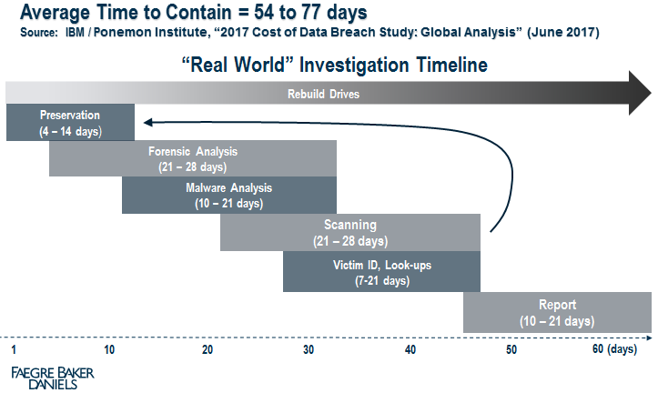

Preventive Measures

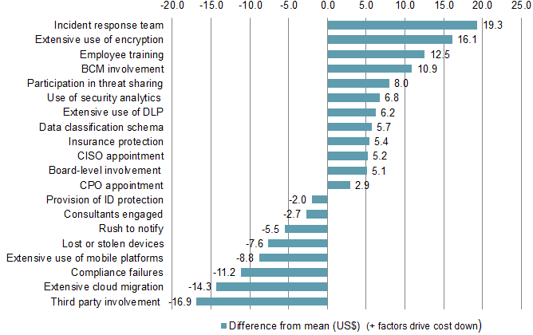

Source: 2017 Cost of Data Breach Study: Global Analysis, Sponsored by IBM, Conducted by Ponemon Institute LLC (June 2017)

